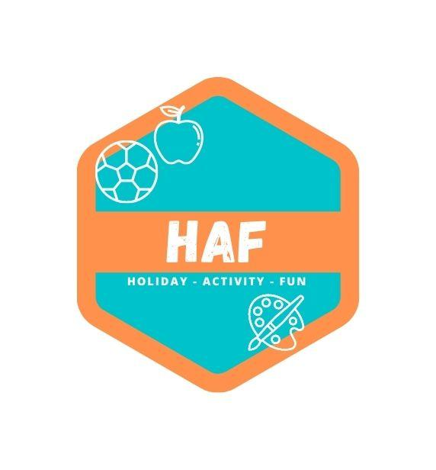

Swimming Policy
West Lancs HAF run a swimming session at the Tarleton Academy site. These sessions are staffed by appropriately qualified Lifeguards.
Our swimming sessions at West Lancs HAF will be based around fun activities in the water for all children, involving the use of floats and other swimming pool toys and will not have a formal lesson structure.
General pool rules
- Our Behaviour Policy applies to the swimming sessions as it would during any other activity
at camp.
- Children must shower and go to the toilet before they enter the water.
- Long hair should be tied back or a swimming hat worn.
- Children should not enter the pool until instructed to do so by a member of staff at the start of
their session.
- Children must leave the pool as soon as the session has finished, once dismissed by the
session leader and should leave in an orderly manner.
- Safety for all is our paramount concern and we have the right to remove any child in or around
the pool who gives us any concern whatsoever with regard to safety.
- Children must not run or act inappropriately once within the pool vicinity. We shall not
be responsible for any injury/accident caused as a result of children disobeying these
rules.
- Children must not enter the swimming pool office at any time.
- Children are lifeguarded at the following ratios:
- 1:10 if all children under the age of 7
- 1:20 if all children are 7 or over the age of 7 (as per public swimming ratios).

This policy was adopted by: West Lancs HAF | Date: 20/03/2023
Reviewed on: 21/06/25  To be reviewed: 21/06/26 | 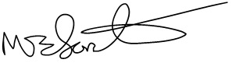  Signed: M.Forster

